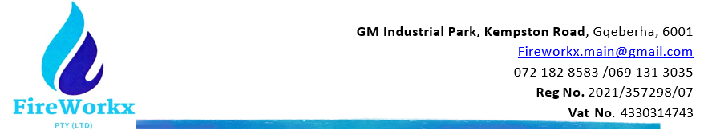

Certificate of Service

Issued to: {clientName}
{siteAddress}
This is to confirm that FireWorkx (PTY) Ltd, Registration 2021/357298/07, has conducted an Annual Service and Installation according to SANS 1475, under accreditation of SACAS, permit number Prod/1475/00195 to the following:

{#equipmentLines}
{.}
{/equipmentLines}

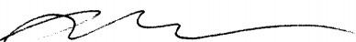
Date: {serviceDate} Signature:
Riekert Swanepoel

